

**Adama Science and Technology University**

**School of Electrical Engineering and Computing**

**Course Title:**Electronic Circuit I

**Course Number:**ECE2101

**Lab:** Experiment Number 5

**Title:**Voltage Multiplier Circuits

**Prepared by:**

**Name ID No.**

**Submitted to: Lecturer Zewdu**

Date of conduction: December 22, 2016

Date of submission: December 29, 2016

**Acknowledgement**

We would like to acknowledge our lab assistantfor his support and explanation in the laboratory. Through the group work and experiment we were able to comprehend the topics that were raised and able to communicate with each other well.

**Theoretical Background**

Voltage-multiplier circuits are employed to maintain a relatively low transformer peak voltage while stepping up the peak output voltage to two, three, four, or more times the peak rectified voltage.

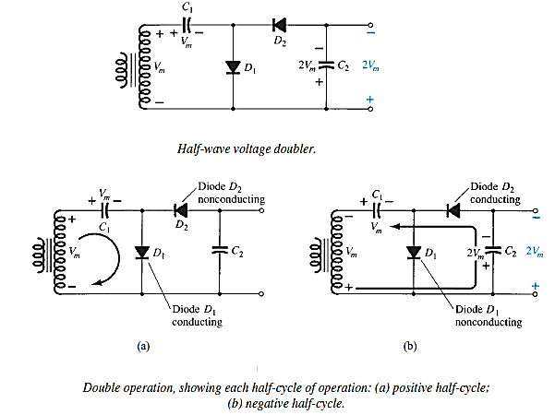

***Figure 1: Half wave voltage doubler and its operations***

During the positive voltage half cycle across the transformer, secondary diode *D*1 conducts (and diode *D*2 is cut off), charging capacitor *C*1 up to the peak rectified voltage (Vm*)*. Diode *D*1 is ideally a short during this half-cycle, and the input voltage charges capacitor *C*1 to *Vm* with the polarity. During the negative half-cycle of the secondary voltage, diode *D*1 is cut off and diode *D*2 conducts charging capacitor *C*2. Since diode *D*2 acts as a short during the negative half-cycle (and diode *D*1 is open).On the next positive half-cycle, diode *D*2 is non-conducting and capacitor *C*2 will discharge through the load. If no load is connected across capacitor *C*2, both capacitors stay charged— *C*1 to *V m* and *C*2 to 2*Vm.* If, as would be expected, there is a load connected to the output of the voltage doubler, the voltage across capacitor *C*2 drops during the positive half-cycle (at the input) and the capacitor is recharged up to 2*Vm* during the negative half cycle. The output waveform across capacitor *C*2 is that of a half-wave signal filtered by a capacitor filter. The peak inverse voltage across each diode is 2*Vm.*

Another doubler circuit is the full-wave doubler of Figure 2. During the positive half-cycle of transformer secondary voltage diode *D*1 conducts, charging capacitor *C*1 to a peak voltage *Vm*. Diode *D*2 is non-conducting at this time. During the negative half-cycle diode *D*2 conducts, charging capacitor *C*2, while diode *D*1 is non-conducting. If no load current is drawn from the circuit, the voltage across capacitors *C*1 and *C*2 is 2*Vm*. If load current is drawn from the circuit, the voltage across capacitors *C*1 and *C*2 is the same as that across a capacitor fed by a full-wave rectifier circuit. One difference is that the effective capacitance is that of *C*1 and *C*2 in series, which is less than the capacitance of either *C*1 or *C*2 alone. The lower capacitor value will provide poorer filtering action than the single-capacitor filter circuit.

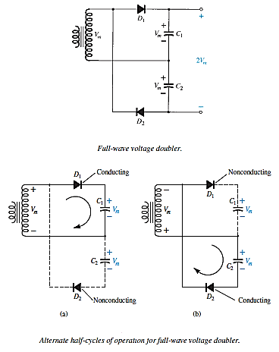

***Figure 2: Half wave voltage doubler and its operations***

The peak inverse voltage across each diode is 2*Vm*, as it is for the filter capacitor circuit. In summary, the half-wave or full-wave voltage-doubler circuits provide twice the peak voltage of the transformer secondary while requiring no center-tapped transformer and only 2*Vm* PIV rating for the diodes.

**Objectives:**

* To analyze Voltage doubler circuits.

**Apparatus Used:**

* AC power supply
* Digital Multimeter (DMM)

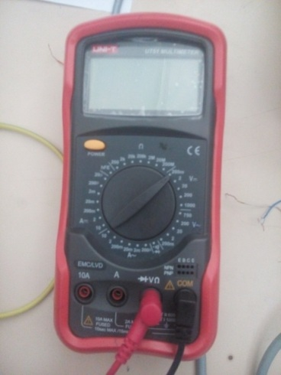****

* Diode: (1N4001)
* Breadboard

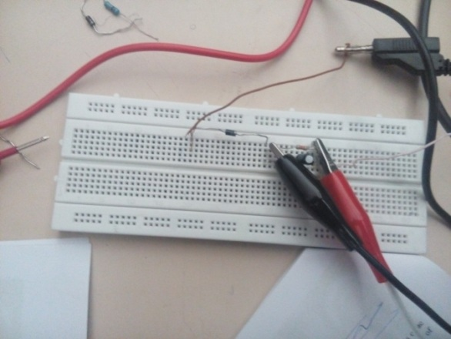

* Oscilloscope

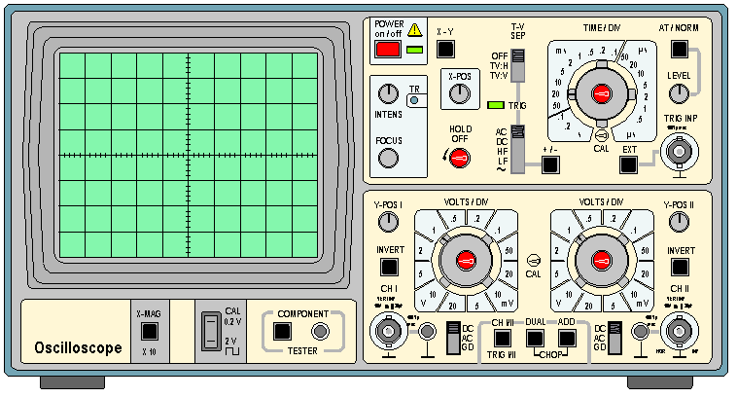

* Connecting Wires
* Capacitors

**Procedures**

**Half-wave Voltage Doubler**

1. First we placed our instruments on a fine surface to begin our experiment.
2. Then we set the peak to peak voltage of the AC power source 12V. Right then we measured the Vrms by using a Digital Multimeter.
3. Thereafter we constructed the circuit shown in Figure 3.
4. Following the above we measured the voltage values of the two capacitors and the load resistor.
5. Finally we measured the ripple voltage by using a DMM.

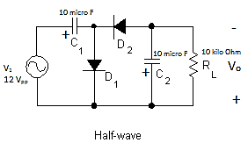

***Figure 3: Half-wave voltage doubler***

**Full-wave Voltage Doubler**

1. We placed and arranged our instruments on a fine surface to begin our experiment.
2. Again we set our peak to peak voltage of the AC power source to 12V.
3. Thereafter we constructed the circuit shown in Figure 4.

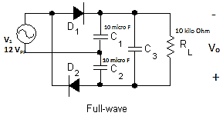

***Figure 4: Full-wave voltage doubler***

1. The same with half-wave doubler, we also measured the voltage across the two capacitors and the load resistor.
2. Finally we measured the ripple voltage by using a DMM.

**Result and Discussion**

After conducting our experiments we have obtained the following results.

|  |  |  |
| --- | --- | --- |
| Voltage Doubler | | |
|  | Half-wave | Full-wave |
| VRL(V) | 8.28 | 9.2 |
| VC1(V) | 8.22 | 4.62 |
| VC2(V) | 4.41 | 4.61 |
| Vrms (V) | 4.31 | 4.52 |
| Vripple(V) | 0.42 | 0.42 |

**Observations and Conclusion**

We have observed the following points:

***Half-wave Voltage Doubler***

* The voltage across the first capacitor is the same as the rms Voltage. However the voltages across the second capacitor and the load resistance are double of the DC voltage.
* To measure the rms voltage (DC voltage) we set our DMM to DC voltage measurer and place it across the source.
* When we wish to measure the ripple voltage we set our DMM to AC voltage measuring mode and place the probes across the resistor. This will tell us how much AC is left in the Multiplied DC voltage.

***Full-wave Voltage Doubler***

* The voltage across each capacitor is the same as the rms voltage, but the load resistor voltage is the double of the rms Voltage.
* The way we measure the ripple and rms Voltages is the same as with the half-wave doubler.

**References**

* Electronic devices and circuit Theory 11th edition, R. L. Boylestad and L. Nashelsky



**Thank you!!!**